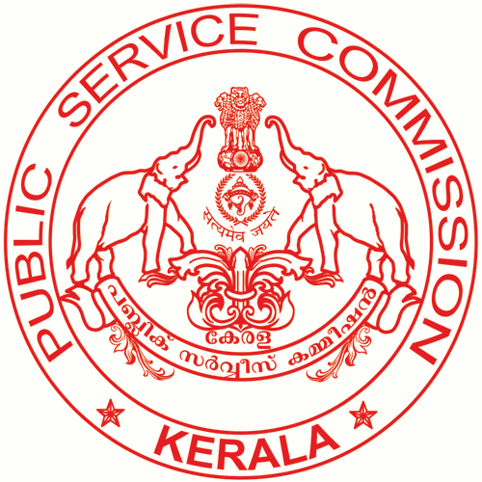

KERALA PUBLIC SERVICE COMMISSION
DISTRICT OFFICE, PALAKKAD

RANKED LIST NO:940/17/DOP Palakkad,
CATEGORY No. 305/2013 Dated: 06.10.2017

NOTIFICATION

The following Ranked list contains the names of candidates found suitable by the Commission on the basis of the result of the Objective Type (OMR) Test held on 19.09.15 and the verification of original documents of candidates included in the Probability List published on 25.04.2017 for selection to the post of Lift Operator (Direct Recruitment) Part I in District Co-Operative Bank Ltd, Palakkad on Rs. 7025-14200/- Category No.305/2013 , Gazette Date : 12.09.2013 arranged in the order of merit. The Ranked List is brought into force with effect from 06.10.17.

The Ranked List shall remain in force for a minimum period of one year provided that the said list will continue to be in force till the publication of new Ranked List after the expiry of minimum period of one year or till three years whichever is earlier. Candidates from this list will be advised for appointment in accordance with the rules and orders regarding reservation and rotation as amended from time to time, if applicable against vacancies reported to the Commission during the pendency of the list. As the advice for appointment depends on the occurrence of vacancies, there is no guarantee that all candidates included in the list will secure appointment. The candidates remaining in the list at the time of cancellation will have no claim at all for appointment on the basis of the inclusion of their names in the list.

Entries put in column 8 (Community) are based on the communities specified by the candidates in their application forms and proved by them with necessary documents. The candidates whose communities have not been correctly noted in the list as proved by them in their applications should intimate the fact to the District Officer, Kerala Public Service Commission District Office, Palakkad within one month from the date of publication of the list to get the benefit of reservation to which they are entitled to. In the absence of timely information regarding discrepancies, if any, the candidates will be advised as incorporated in the list.

According to the existing procedure, re-valuation of Answer Script is not allowed. But re-checking of marks will be done on payment of Rs. 75/- (Rupees Seventy Five). The fee should be remitted in any one of the treasuries in the State under the head of account “0051 PSC - 105 State PSC- 99 Examination Fee”. The fee once remitted will not be refunded on any account. The result of rechecking will be intimated to the candidate from this office. Applications for rechecking of answer scripts should be submitted in the prescribed form available free of cost from the enquiry sections of the various offices of the Commission or its photocopy or downloaded and printed in A4 size paper from the Commission’s website www.keralapsc.gov.in or photocopied therefrom. Applications submitted in any other manner will not be considered. The original chalan receipt together with the application for re-checking should reach the District Officer, K.P.S.C District Office, Palakkad within 45 days from the date on which this Ranked List is brought into force ( i.e. the date on which the ranked list has been approved by the Commission ).

(contd ...2)

Ranked List for the post of Lift Operator (Direct Recruitment) Part I
in District Co-operative Bank Ltd, Palakkad

2

Candidates who wish to obtain a photocopy of their OMR answer sheet (Part A & Part B) relating to this selection shall remit a fee of Rs.300/- (Rupees Three hundred ) by way of chalan in any of the treasuries in the State (Head of Account 0051 PSC-800 State PSC – 99 other receipts). The duly filled up application in the prescribed form (available from the commission’s website) along with the original chalan should be submitted to the District Officer, K.P.S.C District Office, Palakkad within 45 days from the date on which the Ranked List is brought into force. A copy of the answer sheet will be issued only once to a candidate. Candidates are prohibited from applying for copy of answer sheet which is not their own, and legal proceedings will be initiated against those who do so.

“Any candidate can relinquish his/her right for appointment in writing duly attested by a Gazetted Officer of State/Central Government with signature, name, designation and Office Seal,affidavit certified by notary and a self attested copy of photo affixed ID Card. The request for relinquishment received within 15 days from the date of publication of Ranked List in the Official Website of the Commission will be honoured against the requisitions of vacancies that are pending with the Commission up to the finalisation of Ranked list. After the publication of the Ranked List, the request for relinquishment will be considered only if such request is received on or before the date of receipt of requisition, based on which he/she is to be advised.”

Valid applications for rechecking/ photocopy of answer script addressed to District Officer, K.P.S.C District Office, Palakkad shall reach this office within 45 days from the date on which the Ranked List is brought into force. The last date for receipt of applications for rechecking/photocopy of answer script is 20/11/2017. Application for rechecking/photocopy received after the prescribed time limit and not in the prescribed form will not be entertained.

(BY ORDER OF THE COMMISSION)

SHEIK HUSSAIN K M
DISTRICT OFFICER,
KERALA PUB LIC SERVICE COMMISSION
DISTRICT OFFICE, PALAKKAD.

Approved for issue

Section Officer

