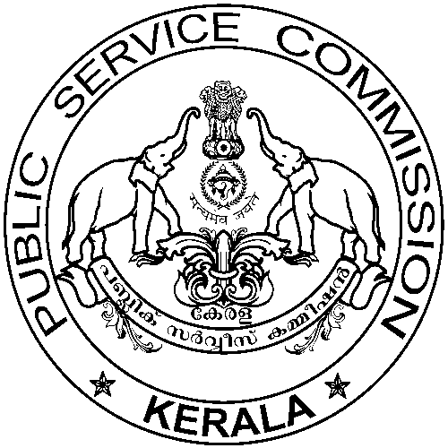

Website: www.keralapsc.gov.in Email:kpsc.psc@kerala.gov.in

Telephone: 0471-2447201

KERALA PUBLIC SERVICE COMMISSION

No. ER VII(1)63/2022/EW Thiruvananthapuram,
Date: 12.01.2022.

Name of Post | : | PART TIME HIGH SCHOOL ASSISTANT (KANNADA)
Department | : | EDUCATION
Date of Test | : | 15/11/2021
Category No. | : | 273/2017 District/Statewise: KASARAGOD
-----------------------------------------------------------------------------------------------------------------------

NOTIFICATION

It is hereby notified that no candidates are invalidated for the above mentioned post.

SECRETARY
KERALA PUBLIC SERVICE COMMISSION

Office of the
Kerala Public Service Commission,
Pattom, Thiruvananthapuram-4.

Approved for Issue,

Section Officer.

