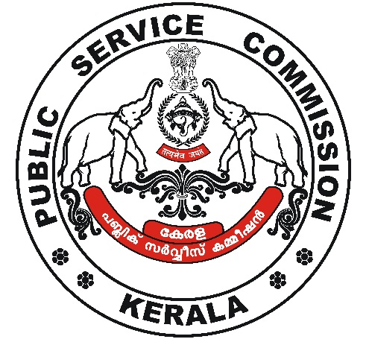
website : www.keralapsc.gov.in E-mail: kpsc.psc@kerala.gov.in
Phone: 0471-2546510

KERALA PUBLIC SERVICE COMMISSION

No. ERXIV(1)4960/23/EW Thiruvananthapuram
Date : 14/11/2023

Name of Post : NON- VOCATIONAL TEACHER IN ENGLISH (JUNIOR)
Department : KERALA VOCATIONAL HIGHER SECONDARY EDUCATION
Date of Test : 24/06/2023 District/ Statewide : STATEWIDE
Category No. : 424/2022

NOTIFICATION

It is hereby notified that no answer scripts are invalidated for the above mentioned post.

SECRETARY
KERALA PUBLIC SERVICE COMMISSION

Office of the
Kerala Public Service Commission
Pattom, Thiruvananthapuram-4

Approved for issue

Section Officer

